

**Wednesday 26 February 2025**

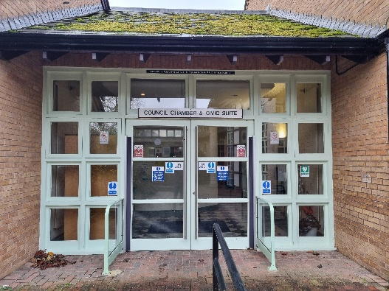**North Kesteven District Council  
 Kesteven Street, Sleaford NG34 7EF**

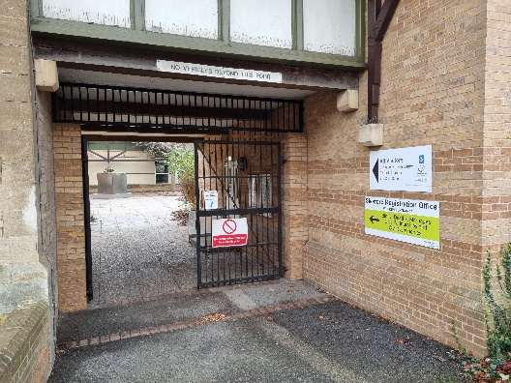

**Open from 10:00 to 14:00 (10am to 2pm)**

****The aim of the open day is to have a ‘one-stop-shop’ for veterans and their families to come along, have a brew and see what services are available, both locally and nationally.

**[Book your FREE ticket with this link](https://buytickets.at/veteranssupportservicecic/1485493)** **or use QR Code:**

Paid parking is available at East Gate & Hub car parks NG34 7DT